**Project 2**

I used semaphore and pthread library to achieve this project instead of using mutex library. Mutex is like a binary semaphore that takes on only the values 0 and 1. But in semaphore library, there are decrement and increment operations, which may result in the blocking of a process and in the unblocking of a process as follows.

After I run this project in both operating systems, which are linux and windows, I get this result with running the input file that includes 6000 lines and each line is 80 bytes.

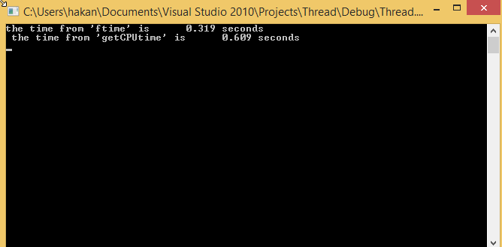

In project 1, I get this result

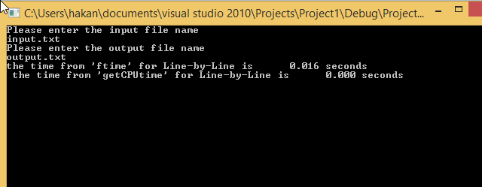

As you can see line by line reading takes lower time, because there were not buffer in project 1. It read from input file and write it to output file at the same time.

After running the project 2 in Linux system, I get this result

the time from 'ftime' is 136.367 seconds

the time from 'getCPUtime' is 131.580 seconds

It takes longer than in Windows systems. It is because of the libraries that Linux use or there is other kind of problems in this Linux. Because I tried same code in remote that is **bingsuns** and I got this output.

the time from 'ftime' for Line-by-Line is 0.291 seconds

the time from 'getCPUtime' for Line-by-Line is 0.287 seconds

In project 1, I got this result for line by line reading.

the time from 'ftime' for Line-by-Line is 0.010 seconds

the time from 'getCPUtime' for Line-by-Line is 0.010 seconds

I used the same code for both operating systems that are Linux and Microsoft.

These codes work for both system.